**Practical – 6**

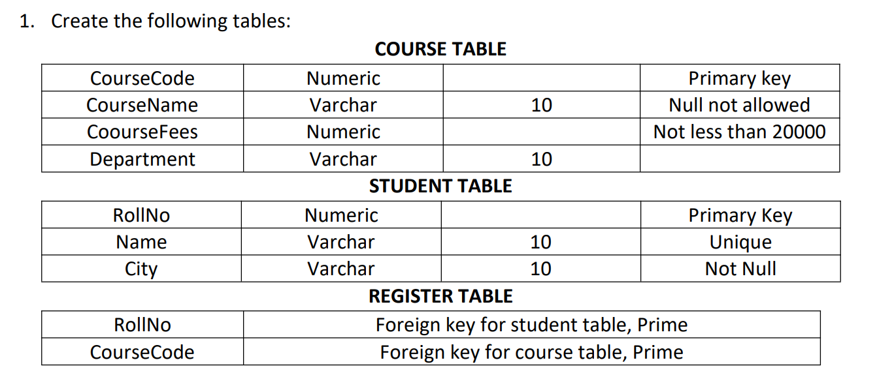

Solution :

CREATE TABLE course (

coursecode NUMBER PRIMARY KEY,

coursename VARCHAR2(10) NOT NULL,

coursefees NUMBER CHECK (coursefees >= 20000),

department VARCHAR2(10)

);

CREATE TABLE student (

rollno NUMBER PRIMARY KEY,

name VARCHAR2(10) UNIQUE,

city VARCHAR2(10) NOT NULL

);

CREATE TABLE register (

rollno NUMBER,

coursecode NUMBER,

PRIMARY KEY (rollno, coursecode),

FOREIGN KEY (rollno) REFERENCES student(rollno),

FOREIGN KEY (coursecode) REFERENCES course(coursecode)

);

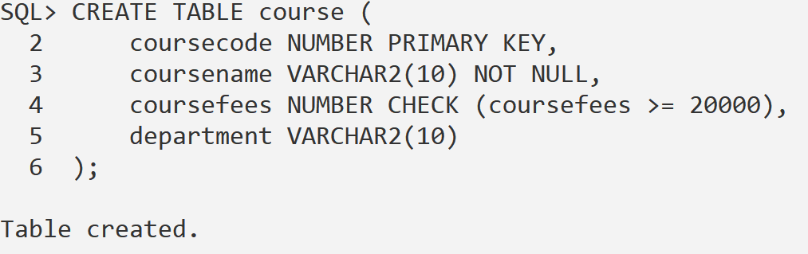  
  
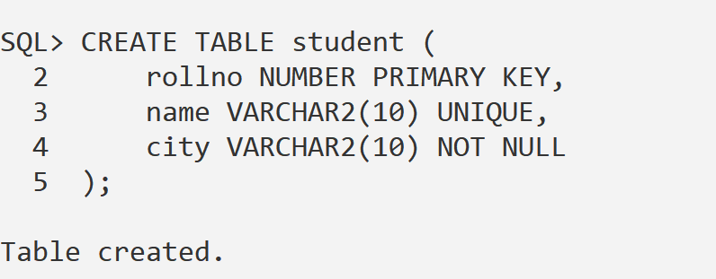  
  
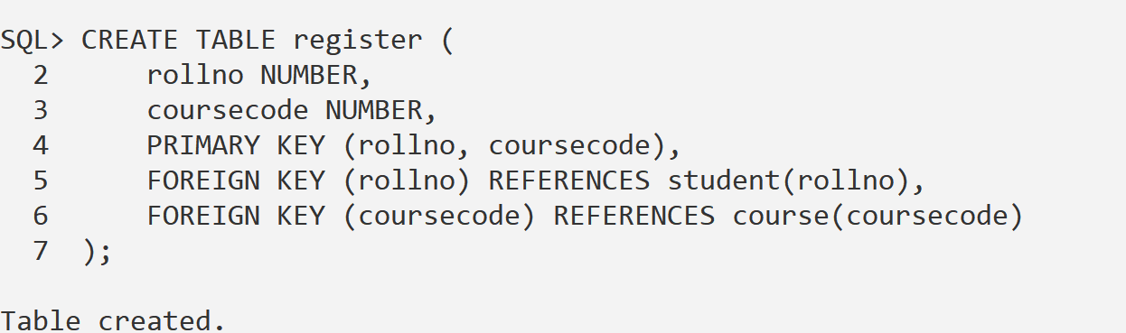

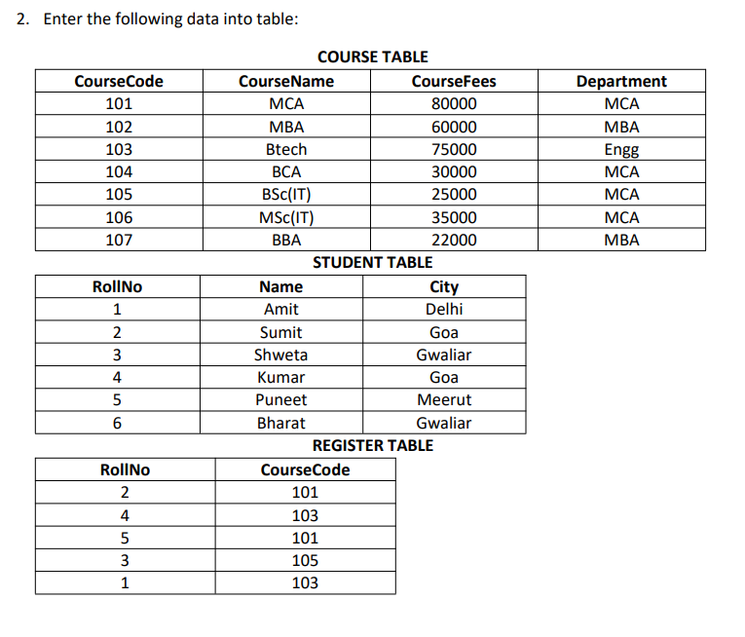

Solution :

INSERT INTO course VALUES (101, 'MCA', 80000, 'MCA');

INSERT INTO course VALUES (102, 'MBA', 60000, 'MBA');

INSERT INTO course VALUES (103, 'Btech', 75000, 'Engg');

INSERT INTO course VALUES (104, 'BCA', 30000, 'MCA');

INSERT INTO course VALUES (105, 'BSc(IT)', 25000, 'MCA');

INSERT INTO course VALUES (106, 'MSc(IT)', 35000, 'MCA');

INSERT INTO course VALUES (107, 'BBA', 22000, 'MBA');  
  
INSERT INTO student VALUES (1, 'Amit', 'Delhi');

INSERT INTO student VALUES (2, 'Sumit', 'Goa');

INSERT INTO student VALUES (3, 'Shweta', 'Gwaliar');

INSERT INTO student VALUES (4, 'Kumar', 'Goa');

INSERT INTO student VALUES (5, 'Puneet', 'Meerut');

INSERT INTO student VALUES (6, 'Bharat', 'Gwaliar');  
  
INSERT INTO register VALUES (2, 101);

INSERT INTO register VALUES (4, 103);

INSERT INTO register VALUES (5, 101);

INSERT INTO register VALUES (3, 105);

INSERT INTO register VALUES (1, 103);  
  
**3. Write queries for the following:**

1. **Details of students who are not registered in any course**

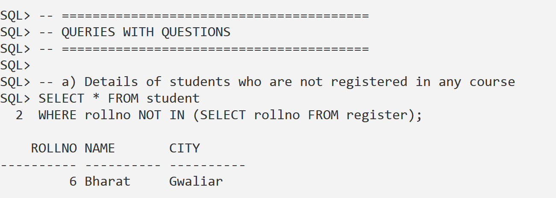

1. **Roll numbers of students not registered in any course**  
   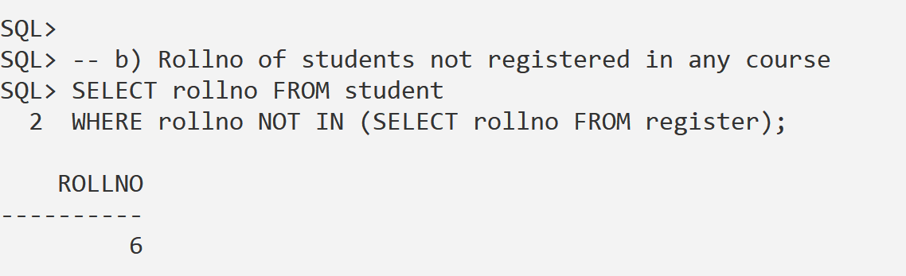
2. **Details of students who are registered in the “MCA” course**  
   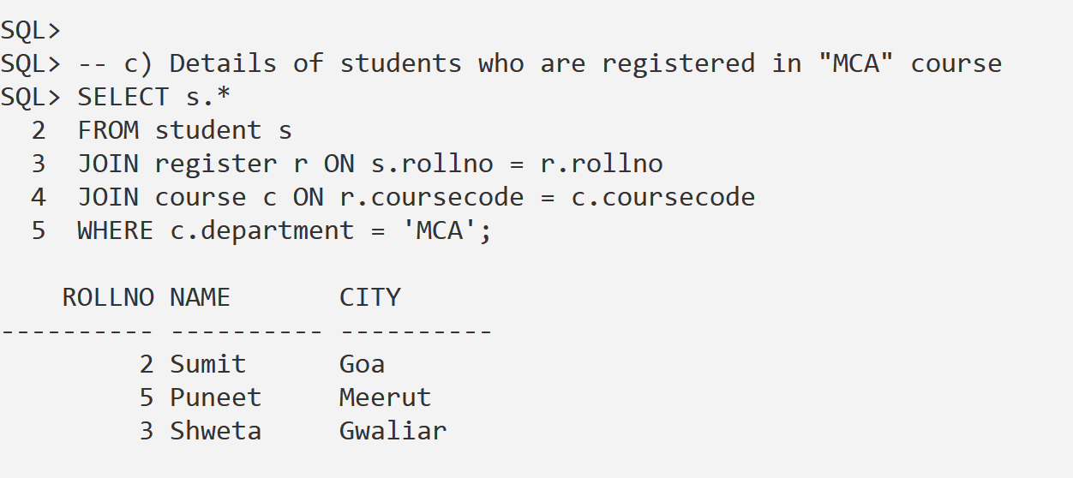
3. **List of courses in which no students are registered**  
   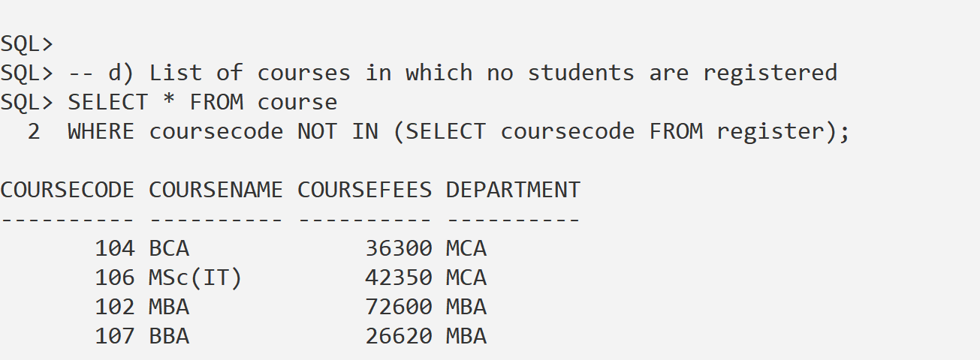
4. **List of courses in which at least one student is registered**  
   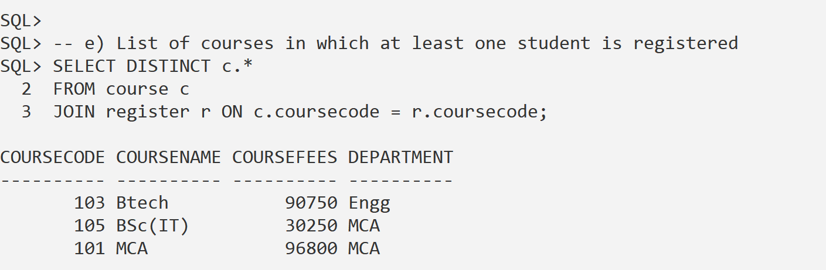
5. **List of students registered in courses having fees greater than the “BCA” course**  
   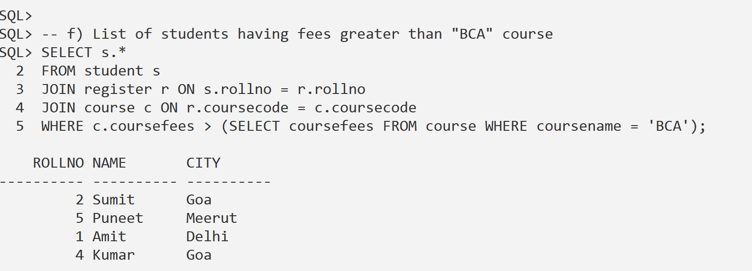
6. **Total fees of all courses and the average course fee**  
   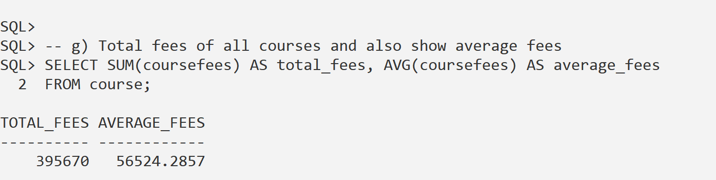
7. **Department-wise total fees of all courses**  
   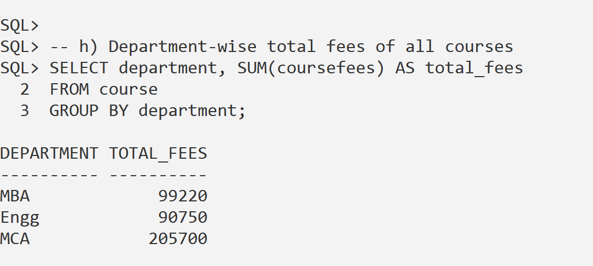
8. **Maximum course fee of each department**  
   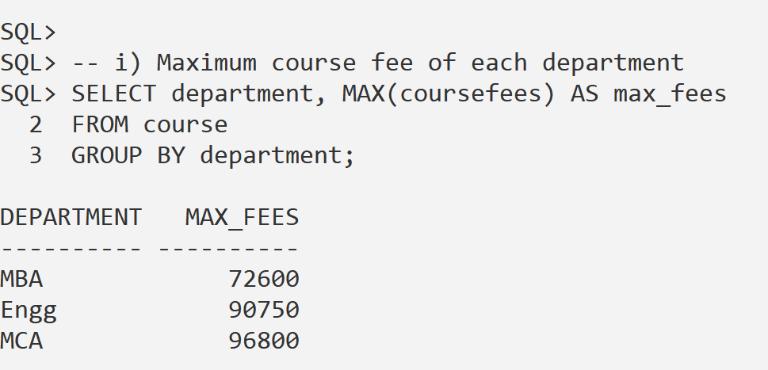
9. **Details of courses with fees greater than the average fee**  
   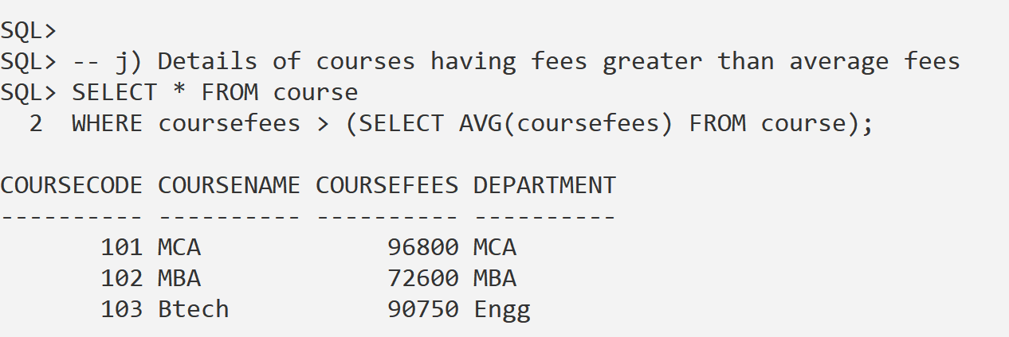
10. **Details of courses in which students from “Goa” are registered**  
    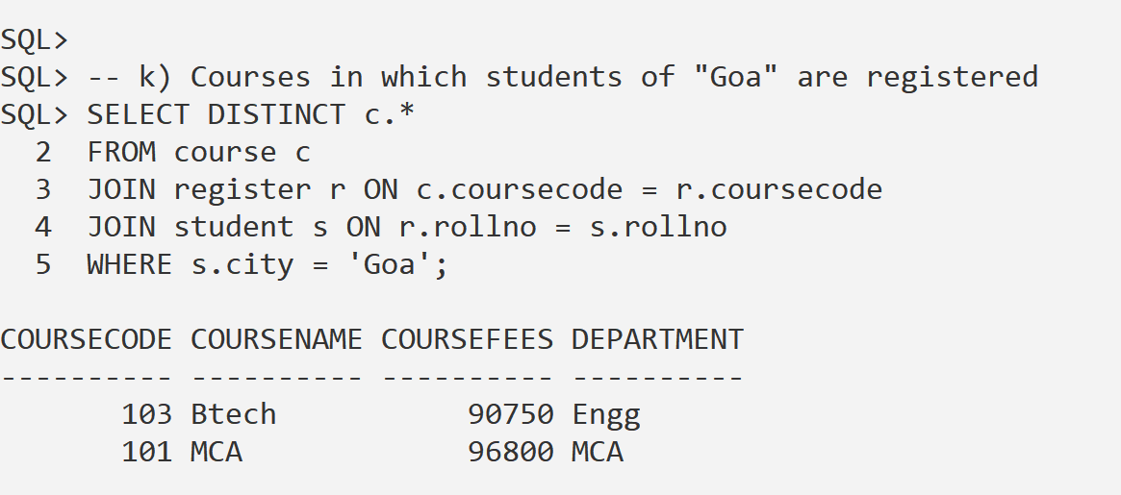
11. **Increase the fees of all courses by 10% and commit the changes**  
    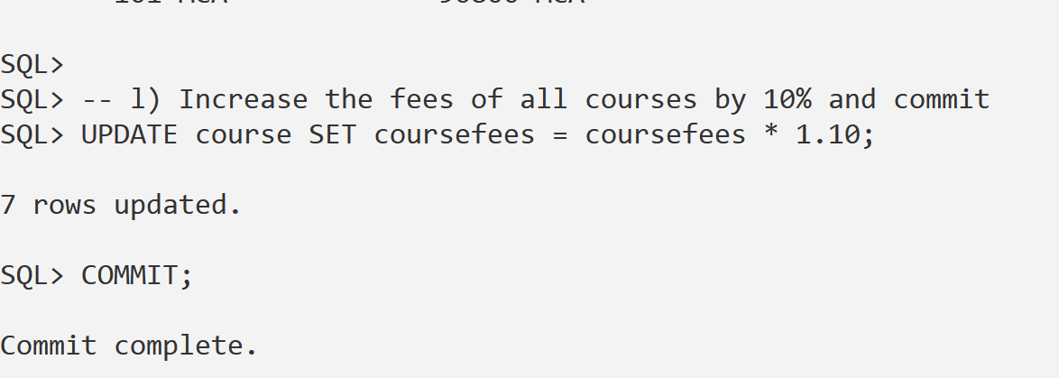
12. **View all records of the course table**

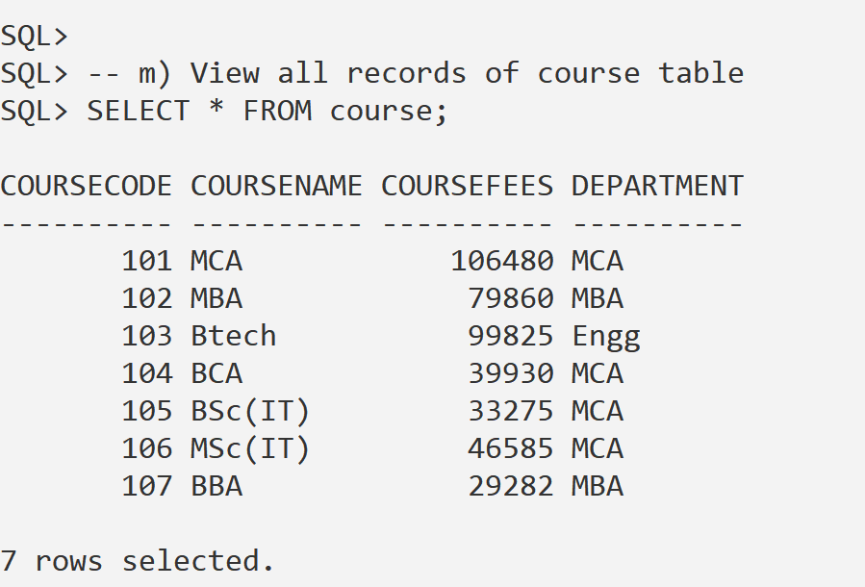

1. **Display the highest, lowest, and average course fees  
     
   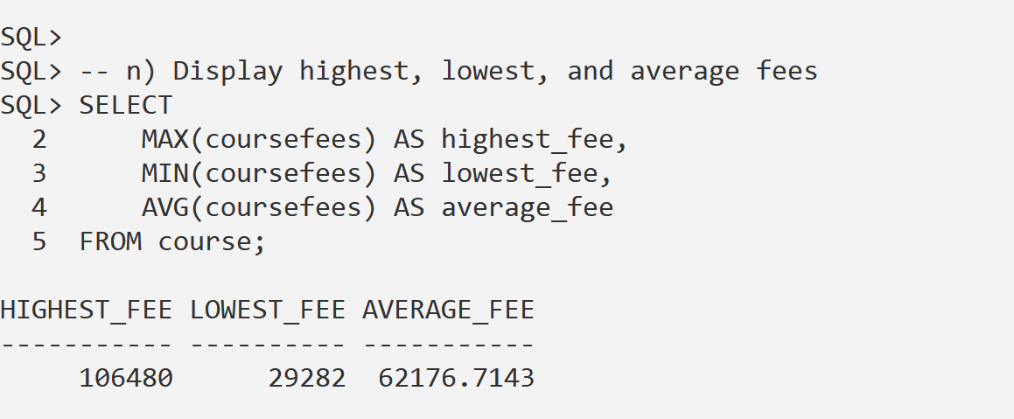**
2. **Names of students who are registered in a course having fees less than 30000  
     
   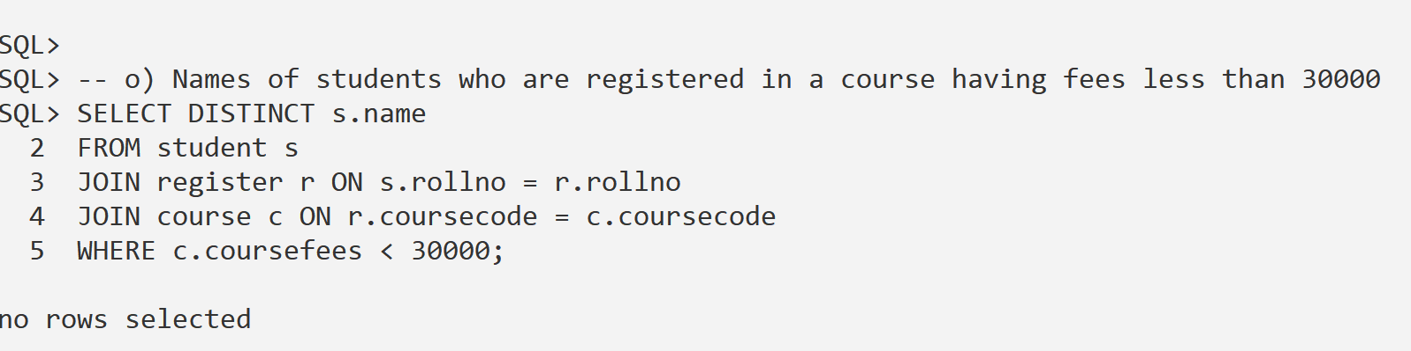**
3. **Display course codes along with the total number of registrations in those courses  
     
   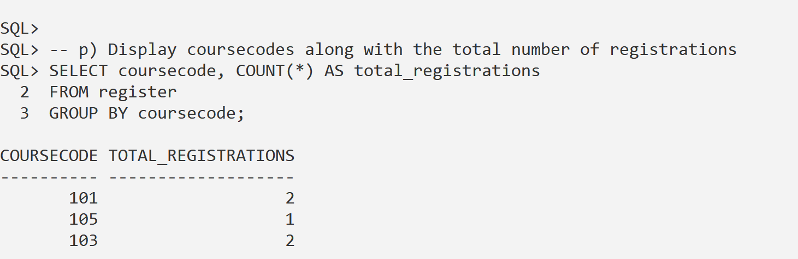**
4. **Display the total number of students from Goa  
     
   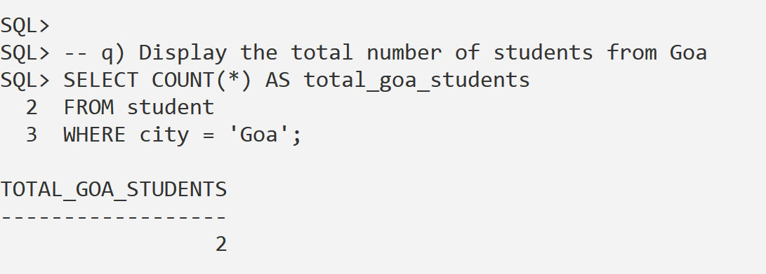**

1. **Display the highest course fee  
     
   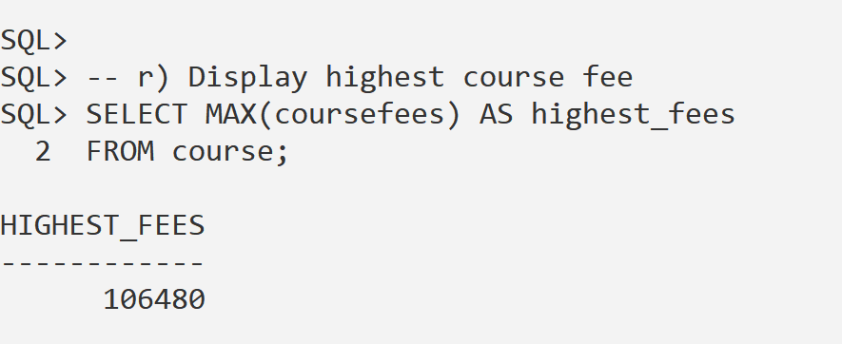**
2. **Display the second highest course fee  
     
   